**Calculator android application project documentation**

**Overview of the Project**

**Introduction**

The Calculator App is a basic but effective tool for performing simple arithmetic calculations. The idea is to give users an easy-to-use interface by which they can carry out mathematical operations such square root, exponential functions, multiplication, division, addition, subtraction, and percentage calculations.

**Features**

Basic Operations:

This application supports addition, subtraction, multiplication, division, and percentage calculations.

Advanced Functions: This application calculates exponential and square root.

User design:  User-friendly design that makes the interaction with application made easier..

Entry handling: Enables smooth entry of calculation and numbers by users.

Error handling: Applied error handling to check the inaccurate inputs and avoid division by zero.

**Challenges Faced and Solutions Implemented**

1. User Interface Design Challenge: It was difficult to create a user interface that was both visually appealing and interactive, especially when attempting to keep things consistent to all screen sizes and orientations.

solution:

Constraint Layout was used to design a user interface that is responsive to different screen sizes. Implemented material design principles, employing square buttons and uniform color palettes to boost usability.

2. Implementing advanced mathematical functions: Adding advanced functions such as square root and exponential calculations posed a challenge, especially in terms of correctly parsing the input and implementing the logic.

Solution:

Created dedicated methods for the square root and exponential calculations to maintain clean and organized code. Updated the allCalculations() method to recognize when these operations are invoked, ensuring the calculations were performed correctly. Utilized the Math.sqrt() and Math.pow() functions in Java to compute square roots and exponentials, respectively, ensuring accuracy in the results.

**Conclusion**

The Calculator application project includes both simple and complex arithmetic operations into a user-friendly Android application. This project supports current standards in software engineering and provides an interactive application with the help of Android development and UI design.

**Screenshots**

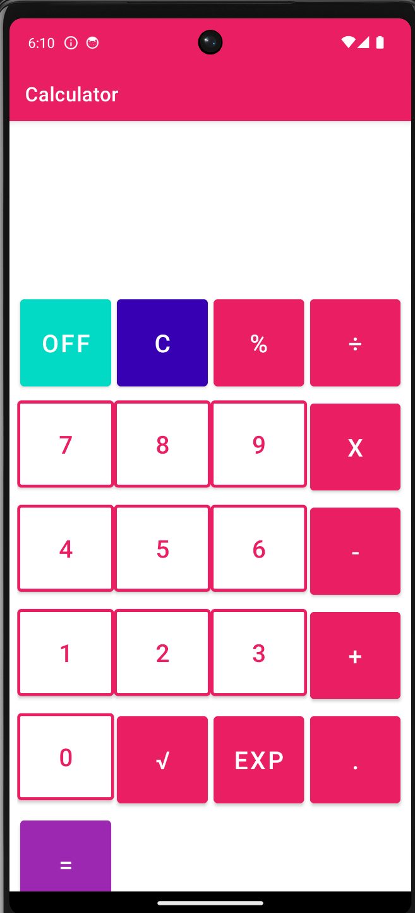

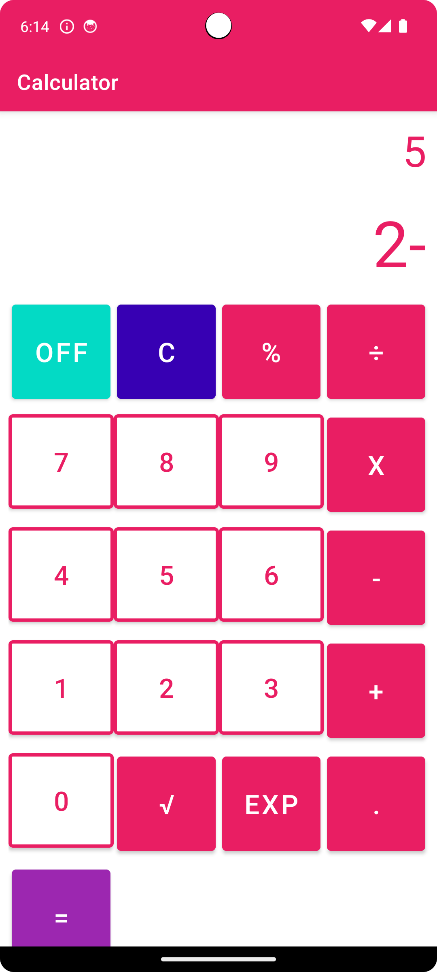

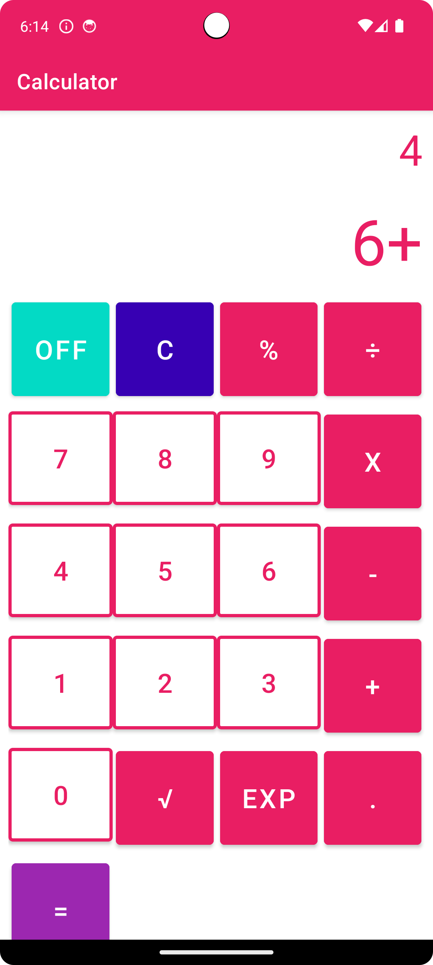

**References**:

<https://www.wikihow.com/Use-a-Calculator>

<https://www.youtube.com/watch?v=PtvQwaUdYdw>

**Video**

